+’-LIBRARIES TO ADD:
TM1637 by AVISHAY ORPAZ
OneWire by Jim Studt
DallasTemperature by Miles Burton

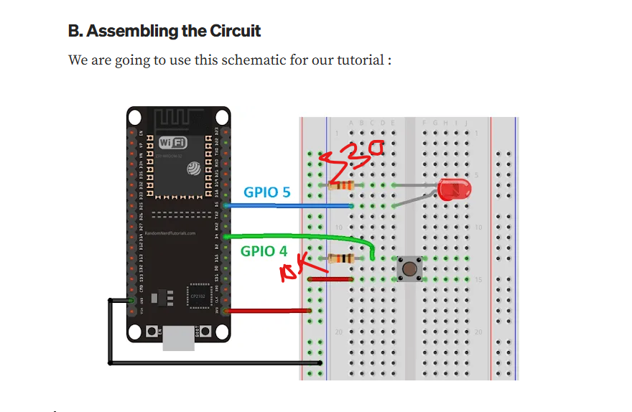
// set pin numbers
const int buttonPin = 4; // the number of the pushbutton pin
const int ledPin = 5; // the number of the LED pin
// variable for storing the pushbutton status
int buttonState = 0;

void setup() {
Serial.begin(115200);
// initialize the pushbutton pin as an input
pinMode(buttonPin, INPUT);
// initialize the LED pin as an output
pinMode(ledPin, OUTPUT);
}

void loop() {
// read the state of the pushbutton value
buttonState = digitalRead(buttonPin);
Serial.println(buttonState);
// check if the pushbutton is pressed.
// if it is, the buttonState is HIGH
if (buttonState == HIGH) {
// turn LED on
digitalWrite(ledPin, HIGH);
}

else {
// turn LED off
digitalWrite(ledPin, LOW);}
}

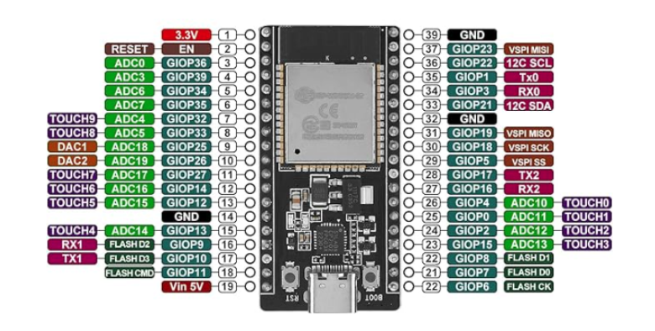

#include <TM1637Display.h>

// Define the CLK and DIO pins connected to the TM1637 display
#define CLK_PIN 2
#define DIO_PIN 4

// Create a display object
TM1637Display display(CLK_PIN, DIO_PIN);

void setup() {
Serial.begin(115200);
display.setBrightness(0x0f); // Set brightness to maximum (0x00 - 0x0f)
}

void loop() {
// Display a number
display.showNumberDec(1234);
delay(2000);

// Display a number with leading zeros
display.showNumberDec(5, true); // Displays 0005
delay(2000);

// Display a number with colon
display.showNumberDecEx(1530, 0b01000000, false, 4, 0); // Displays 15.30 (colon at the second position)
delay(2000);

// Display segments directly (e.g., "TEST")
uint8_t data[] = {
display.encodeDigit(10), // T
display.encodeDigit(14), // E
display.encodeDigit(12), // S
display.encodeDigit(10) // T
};
display.setSegments(data);
delay(2000);

// Clear the display
display.clear();
delay(1000);
}

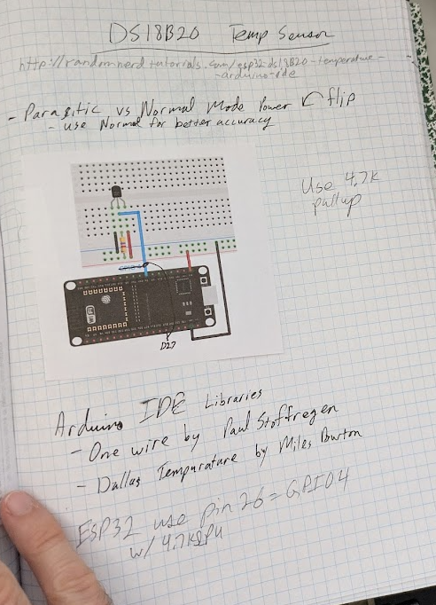
https://randomnerdtutorials.com/guide-for-ds18b20-temperature-sensor-with-arduino/#:~:text=Installing%20Libraries,Temperature%20library%20by%20Miles%20Burton.

https://www.hackster.io/ryanchan/tm1637-digit-display-arduino-quick-tutorial-ca8a93

https://randomnerdtutorials.com/guide-for-ds18b20-temperature-sensor-with-arduino/#:~:text=Installing%20Libraries,Temperature%20library%20by%20Miles%20Burton

https://lastminuteengineers.com/one-channel-relay-module-arduino-tutorial/
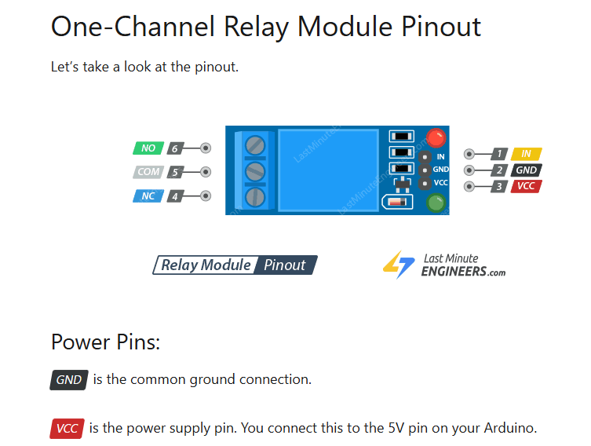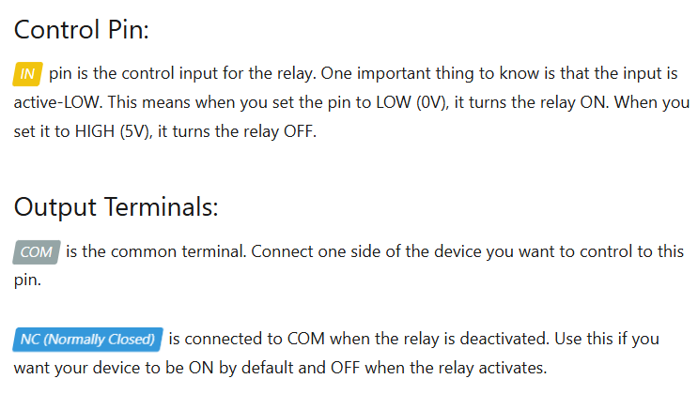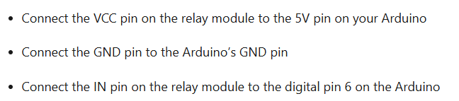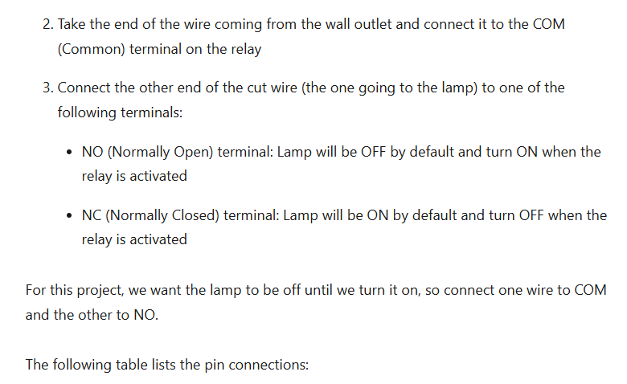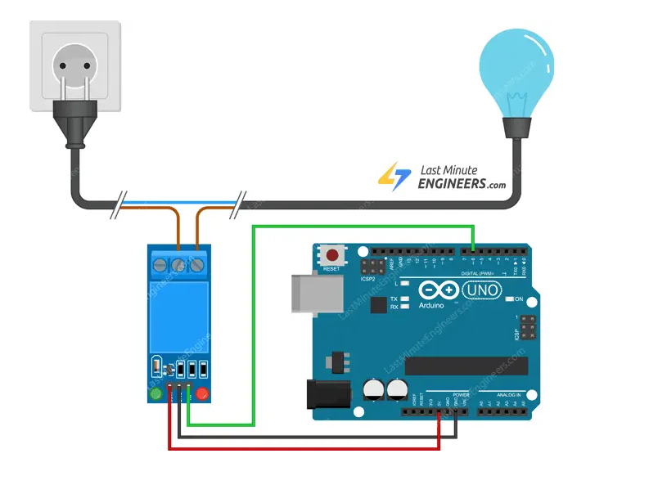int RelayPin = 6;

void setup() {
// Set RelayPin as an output pin
pinMode(RelayPin, OUTPUT);
}

void loop() {
// Let's turn on the relay...
digitalWrite(RelayPin, LOW);
delay(3000);

// Let's turn off the relay...
digitalWrite(RelayPin, HIGH);
delay(3000);
}

